DuckDuckGo is a search engine created in 2008. It has the goal of aiding their users in searching the internet while safeguarding their privacy. The (currently) biggest search engine google, collects and stores personal information for advertisement purposes. DuckDuckGo makes sure that whatever you type in their search engine stays with you. In Cloudflare’s report, DuckDuckGo is reported to have a market share of 0.885%.

How does DuckDuckGo’s page ranking work?

DuckDuckGo does not give a lot of information on how their page ranking algorithm works. On their website they do describe that they get their websites from over 400 different sources like wikipedia. In addition they have their own web crawler DuckDuckBot.

In the rankings section, they explain that due to all the factors, communication on ranking is difficult. The only useful information they do give is that getting links from high quality sites work. This supports the HITS algorithm in some way. Further, generally speaking search engines rank higher quality web sites better so a way to improve page ranking on DuckDuckGo is by making sure that:

* Images include alt tags (these can be read by the crawlers)
* You mention the keywords you want to be found with on your pages
* The website is responsive for mobile users
* Use the language of your target audience
* Meta tags are present

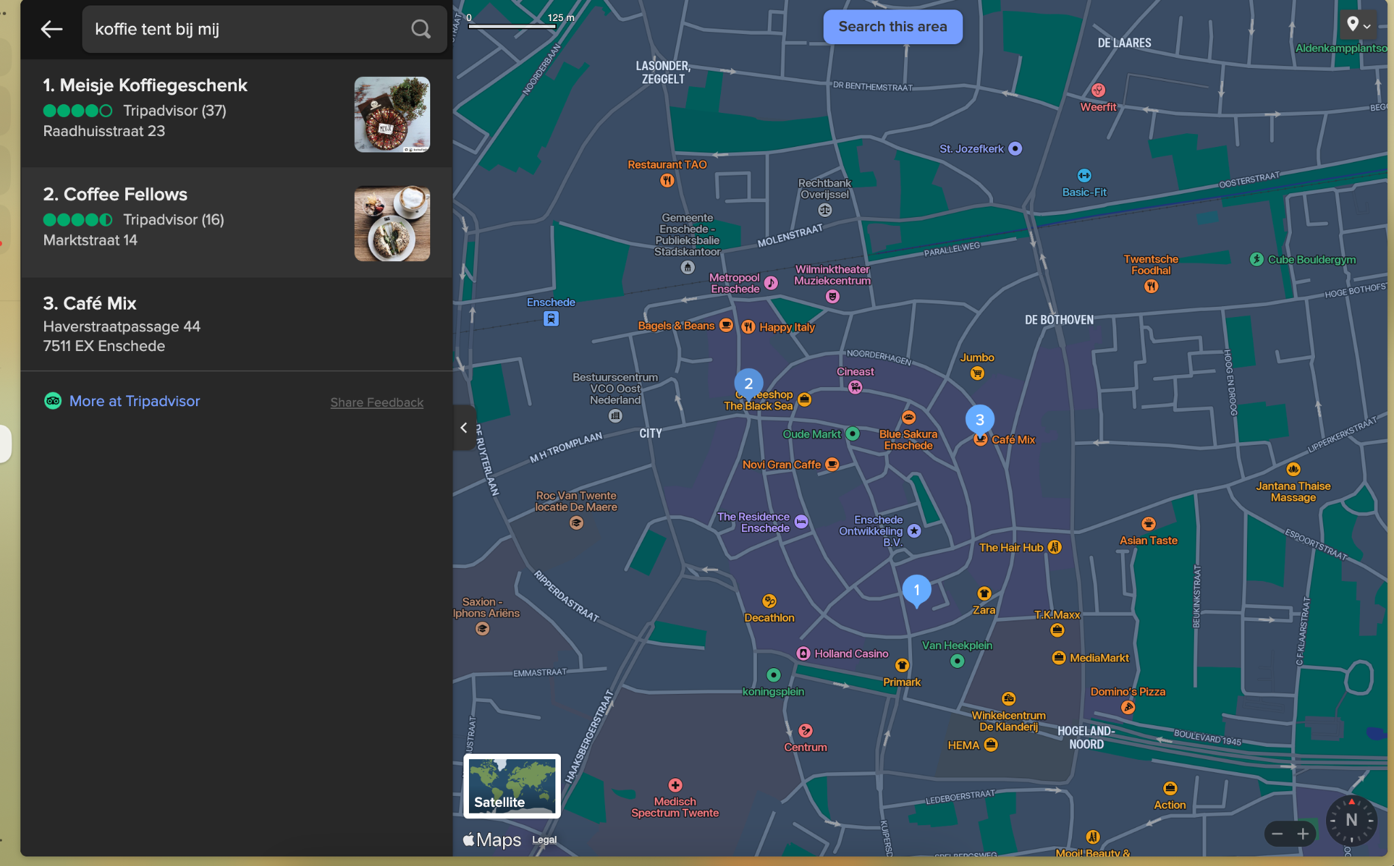

When we test with DuckDuckGo there are a few things that we notice. Localized results are retrieved from Tripadvisor and Apple maps. This means that registering your local business on both of these companies, can help improve page rank

Sources

<https://radar.cloudflare.com/reports/searchengines-2022-q1?ref=spreadprivacy.com>

<https://jbarrett.github.io/duckduckgo-help-pages/results/rankings/>